Text-to-Video Generation
Tanguturu Rohini Vasavi Nichenametla Pranathi Pagade Venkat Sai
CSE: Computer Science & Engineering CSE: Computer Science & Engineering CSE: Computer Science & Engineering
Presidency University (Bng) Presidency University (Bng) Presidency University (Bng)
Bangalore ,India Bangalore ,India Bangalore ,India
vasavirohini6@gmail.com pranathi1305@gmail.com venkatchowdary0806@gmail.com

Dr.Hasan Hussain S
Professor,
School of CSE,
Presidency University,
Bengaluru-560064, India

Abstract
When it comes to creating realistic videos from input text prompts, text-to-video (T2V) diffusion models have demonstrated encouraging capabilities. Nevertheless, there is little control over the exact movements of the objects and the camera framing with just the input text description. In this work, we tackle the motion customization problem, where a reference video is provided as motion guidance. While most existing methods choose to fine-tune pre-trained diffusion models to reconstruct the frame differences of the reference video, we observe that such strategy suffer from content leakage from the reference video, and they cannot capture complex motion accurately. To address this issue, we propose Motion Matcher, a motion customization framework that fine-tunes the pretrained T2V diffusion model at the feature level. Instead of using pixel-level objectives, Motion Matcher compares high-level, spatio-temporal motion features to fine-tune diffusion models, ensuring precise motion learning. For the sake of memory efficiency and accessibility, we utilize a pretrained T2V diffusion model, which contains considerable prior knowledge about

Video motion, to compute these motion features. In our experiments, we demonstrate state-ofthe-art motion customization performances, validating the design of our framework.

1. Introduction
To control the rhythm of a movie scene, movie directors would carefully arrange the precise movements and positioning of both the actors and the camera for each shot (as known as staging/blocking). Similarly, to control the pacing and flow of AI-generated videos, users should have control over the dynamics and composition of videos produced by generative models. To this end, numerous motion control methods have been proposed to control moving object trajectories in videos generated by text-to-video (T2V) diffusion models. Motion customization, in particular, aims to control T2V diffusion models with the motion of a reference video .With the assistance of the reference video, users are able to specify the desired object movements and camera framing in detail. Formally speaking, given a reference video, motion customization aims to adjust a pre-trained T2V diffusion model, so the output videos sampled from the adjusted model follow the object movements and camera framing of the reference video (see Fig. 1 for an example). Given that motion is a high-level concept involving both spatial and temporal dimensions , motion customization is considered a non-trivial task.
Recently, many motion customization methods have been proposed to eliminate the influence of visual appearance in the reference video. Among them, a standout strategy is fine-tuning the pre-trained T2V diffusion model to reconstruct the frame differences of the reference video. For instance, VMC [26] and SMA [36] use a motion distillation objective that reconstructs the residual frames of the reference video. MotionDirector [76] proposes an appearancedebiased objective that reconstructs the differences between an anchor frame and all other frames. However, we find that frame differences do not accurately represent motion. For example, two videos with the same motion, such as a red car and a blue car both driving leftward, can yield completely different frame differences because the pixel changes occur in different color channels in each video. Moreover, since frame differences only process videos at the pixel level, they cannot capture complex motion that requires a high-level understanding of video, such as rapid movements or movements in low-texture regions. In these cases, the strategy of reconstructing frame differences fails to reproduce the target motion.

To address this issue, we propose Motion Matcher, a novel fine-tuning framework for motion customization via motion feature matching. Instead of aligning pixel values or frame differences as in previous methods, Motion Matcher aligns the projected motion features extracted from a pre-trained feature extractor. Since these motion features are calculated with a sophisticated pre-trained model, they are capable of capturing complex motion that requires a high-level, spatio-temporal understanding of video. This effectively addresses the limitation of previous work, where frame differences fail to capture complex motion.
Motion Matcher differs from traditional fine-tuning approaches. At each fine-tuning step, it starts off by using a feature extractor to compute the motion features of the output video and the motion features of the reconstruction ground truth video. Our feature matching objective then minimizes the L2 distance between the two feature vectors. However, since the output videos of T2V diffusion models are in latent space and at certain noise levels, the feature extractor must be able to process latent noisy videos. To obtain such a feature extractor, we take advantages of (1) pre-trained T2V diffusion models’ ability in extracting features from noisy, latent videos and (2) the spatio-temporal information encoded in attention maps. We find that cross attention maps (CA) in pre-trained diffusion models contain information about camera framing, while temporal self attention maps (TSA) represent object movements. Therefore, we utilize them to represent motion features. Ultimately, the design of our framework is validated through detailed analysis and extensive experiments.
To summarize, our key contributions include:
- For motion customization, we suggest Motion Matcher, a feature-level fine-tuning framework. It leverages a pretrained feature extractor to map videos into a motion feature space, capturing high-level motion information. By aligning the motion features, the diffusion model learns to generate videos with the target motion.
- To extract features from noisy latent videos, we utilize the pre-trained diffusion model as a feature extractor, as it naturally processes such inputs.
- We identify two sources of motion cues—cross-attention maps and temporal self-attention maps—and use them to form the motion features.
- We demonstrate that Motion Matcher achieves state-ofthe-art performance through comprehensive experiments. It offers superior joint controllability of text and motion, advancing scene staging in AI-generated videos.
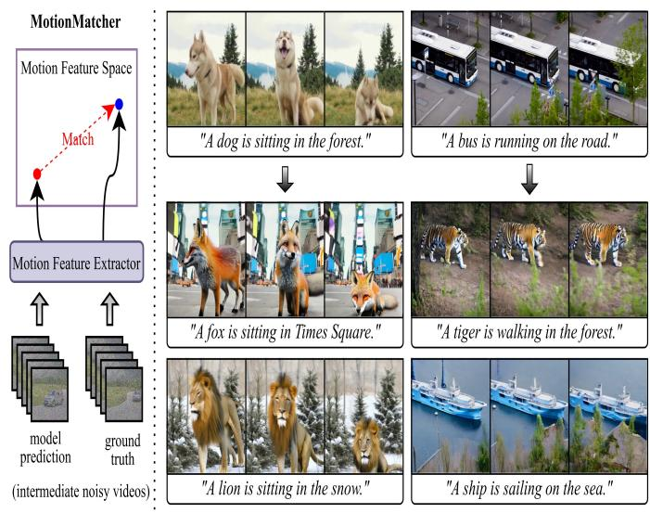
† ‡

Figure 1. MotionMatcher can customize pre-traind T2V diffusion models with a user-provided reference video (top row). Once customized, the diffusion model is able to transfer the precise motion (including object movements and camera framing) in the reference video

to a variety of scenes (middle and bottom rows).

2. Literature Review and Technology Analysis
- Authors / Year | - Reff | - Technique / Model | - Contribution | - Limitation
- [1] Arnab et al. (2021) | - ViViT: Video Vision Transformer | - Transformer for video representation | - Introduced transformer-based architecture for video understanding | - Focused on classification/understanding, not generation
- [2] Balaji et al. (2019) | - Conditional GAN for Text-to-Video | - GAN with discriminative filter | - Early attempt at synthesizing short videos from text | - Low resolution, limited temporal length
- [3] Black & Anandan (1993) | - Optical Flow Framework | - Robust estimation of motion | - Foundational work in motion estimation for videos | - Classical approach, not generative
- [4] Blattmann et al. (2023) | - Align Your Latents | - Latent diffusion for video | - Achieved high-resolution and temporally consistent video synthesis | - Very computationally expensive
- [5] Bruhn et al. (2005) | - Lucas/Kanade + Horn/Schunck | - Combined optic flow methods | - Hybrid approach improving accuracy of flow estimation | - Focused on motion analysis, not direct video generation
- [6] Chen et al. (2023) | - VideoCrafter1 | - Open diffusion model for video | - Open-source, high-quality video generation | - Limited support for long videos and real-time generation
- [7] Dosovitskiy et al. (2015) | - FlowNet | - CNN-based optical flow | - First deep learning model for optical flow estimation | - Restricted to flow estimation, not full video synthesis
- [8] Epstein et al. (2023) | - Diffusion Self-Guidance | - Controllable diffusion | - Added fine-grained control in generative models | - Primarily image-focused, less on videos
- [9] Fan et al. (2017) | - Point Set Generation Network | - 3D reconstruction from images | - Enabled 3D object generation useful for video realism | - Not designed for temporal video synthesis
- [10] Ge et al. (2023) | - Long Video Generation (VQGAN + time-aware) | - Time-agnostic VQGAN | - Generated longer videos with temporal consistency | - High complexity, scaling challenges

3. Related work

3.1. Text-to-video generation
Text-to-video (T2V) generation models aim to synthesize videos that comply with user-provided text descriptions. Previously, a large number of T2V models have been proposed, including GANs ,autoregressive models ,and diffusion models [4, 17, 70].
Following the success of text-to-image (T2I) diffusion models ,researchers have also put considerable effort into training T2V diffusion models recently. To achieve this, a commonly used approach is inflating a pretrained T2I diffusion model by inserting temporal layers and finetuning the whole model on video data .On the other hand, models like Animate Diff [11] and VideoLDM [4] also insert additional temporal layers, but they only finetune the newly-added temporal layers for decoupling purposes. In contrast to the first approach, these models are typically limited to generating simple motion [73]. To ensure motion complexity, we adopt the former type of model as the base model in this work.

3.2. Motion control in T2V generation
To enable detailed control over camera framing and object movements in T2V generation, recent research has explored trajectory-based [59, 63, 65, 72], box-based [25, 33, 57, 61], and reference-based motion control. Trajectory-based and box-based motion control are typically achieved by conditioning T2V diffusion models on additional motion signal and training them on large video datasets [57, 59, 63, 72], or by directly manipulating attention maps at the inference stage [25, 33, 61]. However, these approaches require users to explicitly define the trajectories of moving objects within frames, which is usually laborious and provides limited control over the entire scene. In contrast, reference-based motion control can specify the target motion more comprehensively via a reference video [26, 31, 36, 71, 76]. In this work, we focus on motion customization, which is considered reference-based motion control.

3.3. Motion customization of T2V diffusion models
Recently, motion customization has emerged as a new area of research. It adapts the pre-trained T2V diffusion model to generate videos that replicate the camera framing and object movements of a user-provided reference video. To avoid learning visual appearance, VMC [26] and SMA [36] fine-tune the pre-trained T2V diffusion model by aligning the residual frames of the output video with the residual frames of the reference video. MotionDirector [76] proposes a dual-path fine-tuning method to avoid learning visual appearance and simultaneously utilizes an objective that matches frame differences. However, since frame differences do not accurately represent motion, these methods struggle to replicate complex motion.
Another strategy is using diffusion guidance [8, 14, 34] to achieve controllable generation. In particular, Motion Clone [31] uses intermediate temporal attention maps for guidance, while DMT [71] uses the intermediate spatio-temporal features in diffusion models as a guidance signal. These techniques require the computation of extra gradients during inference, which leads to a time-consuming sampling procedure even though they are training-free. Furthermore, as mentioned in [37, 47], out-of-distribution samples may be produced as a result of the high guidance weights employed in diffusion guidance.
While other motion customization approaches exist, they address different tasks. For instance, DreamVideo [60] and Customize-A-Video [42] focus solely on replicating object movements without preserving the camera framing, whereas MotionMaster [21] deals exclusively with camera movements. In contrast, our method provides control over both object movements and camera framing.

4. Method
Problem formulation To control scene staging in AIgenerated videos, we tackle the problem of motion customization, specifically as defined in DMT [71]. Given a reference video z₀ and a text prompt y associated with it, we aim to adjust a pre-trained T2V diffusion model ϵ_{θ}, so that the output videos sampled from the adjusted model replicate both the object movements and camera framing in z₀.

4.1. Preliminary: Text-to-video diffusion models
Text-to-video (T2V) diffusion models are probabilistic generative models that synthesize videos by gradually denoising a sequence of randomly sampled Gaussian noise frames (in latent space), guided by a textual condition y.
Architecture To model temporal information, T2V diffusion models typically inflate a pre-trained text-to-image (T2I) diffusion model by inserting temporal layers. These temporal layers are made up of feedforward networks and temporal self-

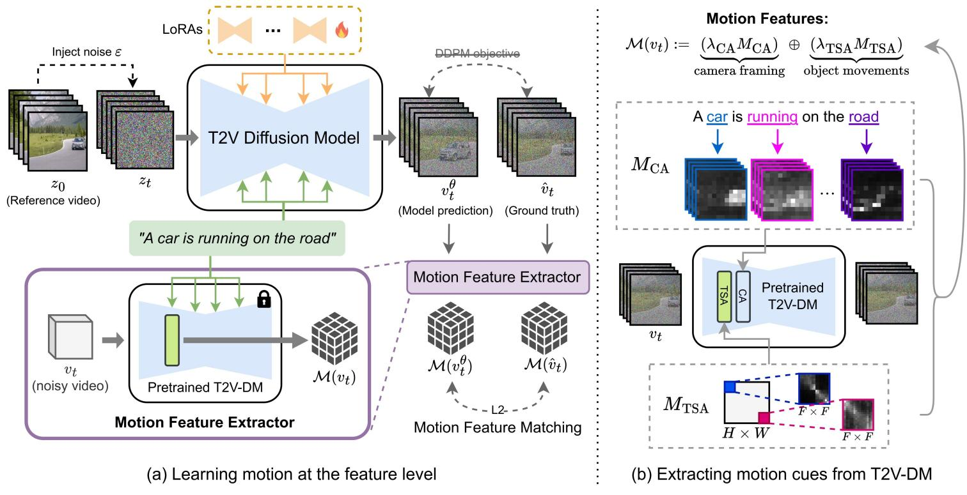
Figure 2. Overview of MotionMatcher. (a) We fine-tune the pre-trained T2V diffusion model (T2V-DM) using the motion feature matching objective. Unlike the standard pixel-level DDPM loss, we align the motion features of the predicted noisy video v_{t}^{θ} with those of the ground truth noisy video vˆ_{t}. To extract motion features from noisy latent videos, we use a pre-trained T2V-DM (frozen) as a feature extractor. (b) We leverage the cross-attention (CA) maps and temporal self-attention (TSA) maps in the pre-trained T2V diffusion model to extract motion cues. The final motion features are the combination of the CA maps and TSA maps.

4.2. Learning motion at the feature level
Identifying motion in video requires a high-level understanding of both the spatial and temporal aspects of the video, so using the standard pixel-level DDPM reconstruction loss (Eq. (3)) for motion customization cannot accurately learn motion, and may introduce irrelevant information, such as content and visual appearance.
To this end, we introduce the motion feature matching objective, where a deep feature extractor M is used to extract motion information from videos at a high level. Instead of directly aligning the predicted noisy video v_{t}^{θ} with the ground truth vˆ_{t} at the pixel level, we align their high-level motion features (extracted by M):

where M is a motion feature extractor for noisy latent videos, and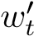 is the time-dependent weight in Eq. (3). As illustrated in Fig. 2(a), this motion feature matching objective aims to minimize the L2 discrepancy between the two videos in the motion feature space, ensuring that the motion in output video matches the motion in the reference video.
However, designing the motion feature extractor M in Eq. (4) is non-trivial, as it needs to extract features from noisy latent videos. First of all, most feature extractors, such as ViViT [1], EfficientNet [52], DenseNet-201 [22], and ResNet-50 [12], are trained on clean visual data, so we cannot directly applied them to noisy videos. Secondly, since the videos vˆ_{t} and v_{t}^{θ} in Eq. (4) are in latent space, our feature extractor must be designed to process latent videos directly. Otherwise, we would need to decode them back into pixel-space videos before applying off-the-shelf feature extractors. This would incur substantial computational and memory overhead during training, due to both backpropagation through the large VAE decoder and the cost of processing “full-resolution” videos.
Here we claim that the pre-trained T2V diffusion model serve as a proper feature extractor for noisy latent videos. Firstly, recent work has shown both theoretically and experimentally that pre-trained diffusion models are capable of extracting high-level semantics and structural information from visual data, making them a “unified feature extractor” [64, 67]. Secondly, since diffusion models are trained on noisy latent inputs, using them as feature extractors for noisy latent videos helps prevent a training-inference gap. For these reasons, MotionMatcher leverages the pretrained T2V diffusion model as the motion feature extractor M.

4.3. Extracting motion cues from diffusion models
In this section, we identify the locations within the intermediate layers of diffusion models from which motion-specific features can be extracted.
Extracting cues for camera framing Recent studies have shown that the cross-attention (CA) maps in diffusion models closely reflect the spatial arrangement of objects within the frame [25, 33, 44, 66, 69]. Building on this, we leverage the CA maps from T2V diffusion models to describe the composition of each video frame (see Fig. 2(b)), thereby determining the camera framing throughout the video (e.g., shot size and composition).
Formally speaking, CA maps are calculated by first reshaping the intermediate 3D activations Φ ∈ R^{H×W×F×D} into the shape (H × W × F) × D, where F, H, W, and
D denote the number of frames, height, width, and depth of the activations. Cross-attention is then performed between the activations Φ and word embeddings τ(y) as follows :
(5)
where τ denotes the text encoder used in the T2V diffusion model, and y is the text prompt given by the user. In MCA ∈ [0,1]F×H×W×|c|, each element (MCA)i,j,k,l represents the correlation between the spatial-temporal coordinate (i,j,k) and the l’th word in the text prompt. As shown in Fig. 3, M_{CA} highlights the region within the frame that corresponds to an object. It focuses on structural information and eliminates visual appearance.
Extracting cues for object movements Since cross attention maps cannot describe motion that does not involve spatial shifts (e.g., rotation and non-rigid motion), it is crucial to extract additional cues to represent such object movements. Since we discover that the temporal self-attention (TSA) maps in T2V diffusion models can capture detailed object movements, we also incorporate them into the motion features (see Fig. 2(b)).
To compute temporal self-attention (TSA) maps M_{TSA}, we begin by reshaping the model’s intermediate 3D activations Φ ∈ R^{H×W×F×D} into the shape (H ×W)×F ×D.
For each particular spatial coordinate (i,j), we compute the self-attention weights between frames as follows:

where i and j denote the spatial coordinates. Specifically, each element (M_{TSA})_{i,j,k,l} of the TSA map M_{TSA} ∈ [0,1]^{H×W×F×F} represents the degree of relevance between the k’th and l’th frames at the spatial coordinate

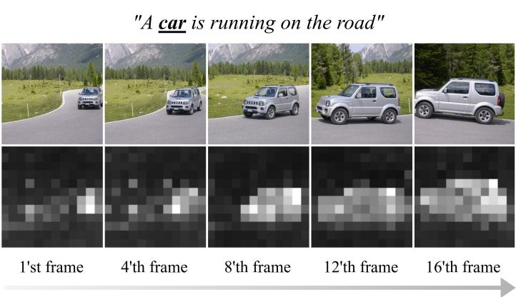

Figure 3. Example of cross-attention maps. We visualize the cross-attention map M_{CA}, computed between the activations in T2V diffusion models and the text prompt y. Here we obtain the CA map by adding noise to the video and using the pre-trained diffusion model as a feature extractor. The extracted CA maps reveal the placement and shot sizes of the object associated with the word “car” in each video

frame.
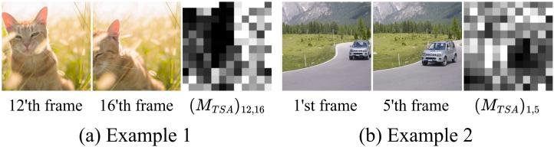

Figure 4. Example of temporal self-attention maps. We visualize the temporal self-attention map M_{CA}, computed between two different frames. Here we obtain the TSA map by adding noise to the video and using the pre-trained diffusion model as a feature extractor. The extracted TSA maps describe the dynamics of the video in detail.
(i,j), capturing the dynamics of the video. As visualized in Fig. 4, the darker regions, which indicate low correlation between frames, correspond closely to areas where significant changes occur between the two frames. Therefore, by collecting the TSA maps for all F × F frame pairs, we can capture the inter-frame dynamics in detail.
With the cross-attention maps capturing camera framing, and the temporal self-attention maps reflecting object movements, we combine both to form the motion features:
(6)
where λ_{CA} and λ_{TSA} are weights that control the contributions of each component.

3.4. Motion-aware LoRA fine-tuning
After extracting the motion features, we fine-tune the pretrained T2V diffusion model using the motion feature matching objective in Eq. (4). By aligning the M_{CA} component, we ensure that the camera framing in the generated video matches that of the reference video, and align-

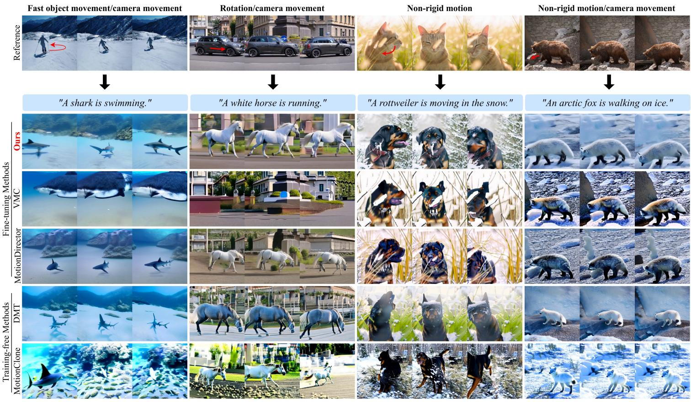
Figure 5. Qualitative comparisons. Compared to existing methods such as VMC [26], MotionDirector [76], DMT [71], and Motion-
Clone [31], our approach demonstrates superior text alignment and video quality, achieving high-fidelity motion transfer from reference

videos to new scenes.
ing M_{TSA} ensures that the dynamics in the generated video align with those of the reference video.
To preserve the model’s pre-trained knowledge while fine-tuning, we apply low-rank adaptations (LoRAs) [20] to fine-tune the model with fewer trainable parameters:
(7)

where ∆θ is a low-rank parameter increment. Having these motion-aware LoRAs, MotionMatcher is capable of synthesizing videos that are guided by both the textual description and the motion in the user-provided reference video.

5. Experiments

5.1. Experiment setup
Dataset To evaluate MotionMatcher’s ability to transfer motion from a reference video to a new scene, we collect a dataset of 42 video-text pairs. These videos encompass a wide range of motion types, such as fast object movement, rotation, non-rigid motion, and camera movement. We also ensure that the scenes in the editing text prompts are distinct from the scene in the reference video while remaining compatible with its motion.
Implementation details For a fair comparison, we use Zeroscope [50] as the base T2V diffusion model across all methods, given its ability to model complex motion and widespread usage in previous work [36, 71, 76]. We finetune the model with LoRA [20] for 400 steps at a learning rate of 0.0005. To extract motion features, we obtain attention maps M_{CA} and M_{TSA} from down block.2, with weights λ_{CA} and λ_{TSA} both set to 2000. These hyperparameters are selected to strike a balance between object movements and camera framing control. To prevent needless computation, we halt the forward pass after extracting features from intermediate layers. Please consult the supplemental material for additional implementation details.
Starting points We contrast our approach with four recent motion customization approaches: two training-free methods (DMT [71] and MotionClone [31]) and two fine-tuning methods (VMC [26] and MotionDirector [76]). These techniques are described in detail in Sec. 2.3.

5.2. Evaluation metrics
We use four automatic metrics to evaluate the effectiveness of motion customization: (1) CLIP-T: To measure text
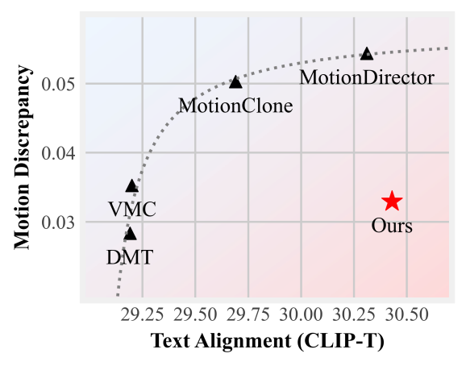
alignment, we determine the average CLIP [39] cosine similarity between each output frame and the text prompt. (2) Frame consistency: To evaluate frame consistency, we calculate the average CLIP cosine similarity between every pair of consecutive frames. (3) Image Reward: Based on human preference, we determine the average Image Reward [68] score for every frame, which assesses both text alignment and image quality. (4) Motion discrepancy: We use CoTracker3 [27], a cutting-edge point tracker that densely tracks the motion trajectories of 2D points throughout a video, to measure the motion similarity between reference and generated videos. Specifically, we use CoTracker3 to generate N 2D point trajectories for the reference video, denoted as T^{ˆ}₀,T^{ˆ}₁,··· ,T^{ˆ}_{N} ∈ R^{F×2}, and N 2D point trajectories for the generated video, denoted as T₀,T₁,··· ,T_{N} ∈ R^{F×2}. To measure the similarity between these two sets of F × 2 dimensional vectors, we use the Chamfer distance, a metric commonly used to assess the similarity between two sets of points in point cloud generation [9, 32, 53, 75]. Accordingly, the motion discrepancy score is defined as:
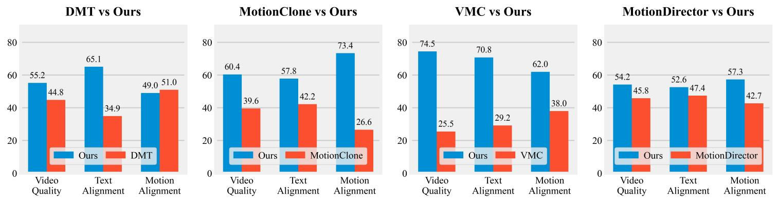
Figure 6. Human user study. The results show that human raters prefer our method over existing approaches in terms of video quality, text alignment, and motion alignment.
Methods | CLIP-T (↑) | ImageReward (↑) | Frame Consistency (↑) | Motion Discrepancy (↓)
DMT∗  MotionClone∗  VMC | 29.20 | 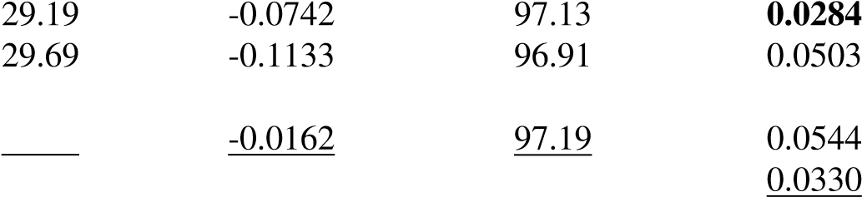-0.3292 | 96.89 | 0.0353
MotionDirector | 30.31
Ours | 30.43 | 0.2301 | 97.20
Table 1. Quantitative evaluation. Our method outperforms baseline approaches in text alignment, frame consistency, and overall human preference as measured by ImageReward [68]. Note that ∗ denotes diffusion guidance-based methods.

5.3. Main results
Quantitative results The quantitative results are reported in Tab. 1. Our method outperforms all baseline approaches in metrics such as CLIP-T, frame consistency, and ImageReward, demonstrating its superiority in preserving the prior knowledge in the base model during fine-tuning.
We also visualize the trade-off between text controllability and motion controllability in Fig. 7. As shown, our method provides significantly better joint controllability of both text and motion than existing motion customization approaches.
Qualitative results In Fig. 5, we present qualitative comparisons with baseline approaches across various types of motion. In the first example, only our method successfully reproduces the fast displacement in the reference video, confirming the effectiveness of our motion feature extractor in capturing complex motion. In the second example, VMC and MotionClone misposition the object within the frame, whereas MotionDirector and DMT fail to generate realistic videos complying with the text prompt. In contrast, our method faithfully follows the text prompt and places the object correctly. In the third and forth examples, our method also exhibits superior visual and motion quality.
These results conclude that our method preserves the most pre-trained knowledge during fine-tuning, while providing the strongest controllability for complex motion. For more results, please refer to Fig. 1 and the appendix.

6. Ablation study
We conduct an ablation study to examine the impact of incorporating M_{CA} and M_{TSA} in motion features. Without cross-attention maps MCA, the model finds it difficult to accurately position every element in the scene, as shown in Fig. 8. The accuracy of fine-grained dynamics is decreased when temporal self-attention maps (MTSA) are eliminated. The significance of both attention maps in motion control is further supported by the quantitative findings in Tab. 2. These findings validate that capturing overall motion requires both inter-frame dynamics, which are informed by MTSA, and camera framing, which is informed by MCA.

6.1. Human user study
We compare our method with existing approaches based on human preferences in a user study for a more accurate assessment. We use the Two-alternative Forced Choice (2AFC) protocol in accordance with earlier research [71,76]. Participants in the survey are shown two videos: one produced using our method and the other using a baseline approach. They are requested to evaluate the videos in light of three crucial motion customization factors: (1) Video quality: how realistic and visually appealing the final video is; (2) Text alignment: how well the final video adheres to the text prompt; and (3) Motion alignment: how closely the final video and the reference video move in tandem. In the end, we gathered 2,304 human evaluations, 192 for each baseline and metric.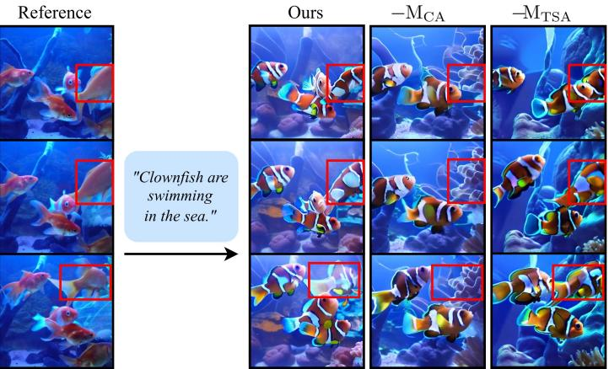
Figure 8.Qualitative Findings: Ablation Study. The model cannot capture all fish in the video when not using cross-attention maps MCA in motion features; in the same way, the model struggles to match fine-grained motion detail when not using temporal self-attention maps MTSA. Our method preserves scene composition as well as the interframe dynamics of the reference video.
 | CLIP-T (↑) | ImageReward (↑) | Motion Discrep. (↓)
−CA | 30.08 | 0.1252 | 0.0360
−TSA | 30.67 | 0.4650 | 0.0693
Ours | 30.43 | 0.2301 | 0.0330
Table 2. Ablation study. Our method, which utilizes both M_{CA} and M_{TSA}, achieves the lowest motion discrepancy score.
As shown in Fig. 6, human users prefer our method over existing approaches in all aspects. These results further confirm the superiority of our method.

7. Conclusion
We introduced Motion Matcher, a framework designed for feature-level fine-tuning to enable motion customization. By making it aim to learn the target motion in the feature space, Motion Matcher converts the pixel-level DDPM objective into the motion feature matching objective. To utilize motion features, we first employ the pre-trained T2V diffusion model to provide deep feature extraction and discover secondary motion cues from two or more attention mechanisms in the model that represent the character movements as well as the camera framing of the videos. In our experiments, Motion Matcher demonstrated superior joint controllability of text and motion as compared with previous methods. These results indicate that our approach affords motion customization and control over scene staging in AI-generated videos with applications to practical situations in computer-generated imagery (CGI). For a discussion of the limitations of Motion Matcher, see the supplementary material.

References
- Anurag Arnab, Mostafa Dehghani, Georg Heigold, Chen Sun, Mario Luciˇ c, and Cordelia Schmid.´ Vivit: A video vision transformer. In Proceedings of the IEEE/CVF international conference on computer vision, pages 6836–6846,
2021. 4
- Yogesh Balaji, Martin Renqiang Min, Bing Bai, Rama Chellappa, and Hans Peter Graf. Conditional gan with discriminative filter generation for text-to-video synthesis. In IJCAI, page 2, 2019. 2
- Michael J Black and Padmanabhan Anandan. A framework for the robust estimation of optical flow. In 1993 (4th) International Conference on Computer Vision, pages 231–236. IEEE, 1993. 2
- Andreas Blattmann, Robin Rombach, Huan Ling, Tim Dockhorn, Seung Wook Kim, Sanja Fidler, and Karsten Kreis. Align your latents: High-resolution video synthesis with latent diffusion models. In Proceedings of the IEEE/CVF Conference on Computer Vision and Pattern Recognition, pages 22563–22575, 2023. 2, 3
- Andres Bruhn, Joachim Weickert, and Christoph Schn´ orr.¨ Lucas/kanade meets horn/schunck: Combining local and global optic flow methods. International journal of computer vision, 61:211–231, 2005. 2
- Haoxin Chen, Menghan Xia, Yingqing He, Yong Zhang, Xiaodong Cun, Shaoshu Yang, Jinbo Xing, Yaofang Liu, Qifeng Chen, Xintao Wang, et al. Videocrafter1: Open diffusion models for high-quality video generation. arXiv preprint arXiv:2310.19512, 2023. 2
- Alexey Dosovitskiy, Philipp Fischer, Eddy Ilg, Philip Hausser, Caner Hazirbas, Vladimir Golkov, Patrick Van Der Smagt, Daniel Cremers, and Thomas Brox. Flownet: Learning optical flow with convolutional networks. In Proceedings of the IEEE international conference on computer vision, pages 2758–2766, 2015. 2
- Dave Epstein, Allan Jabri, Ben Poole, Alexei Efros, and Aleksander Holynski. Diffusion self-guidance for controllable image generation. Advances in Neural Information Processing Systems, 36:16222–16239, 2023. 3
- Haoqiang Fan, Hao Su, and Leonidas J Guibas. A point set generation network for 3d object reconstruction from a single image. In Proceedings of the IEEE conference on computer vision and pattern recognition, pages 605–613, 2017. 7
- Songwei Ge, Thomas Hayes, Harry Yang, Xi Yin, Guan Pang, David Jacobs, Jia-Bin Huang, and Devi Parikh. Long video generation with time-agnostic vqgan and timesensitive.

